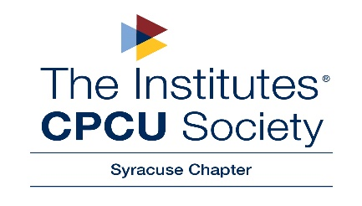

March Ethics Lunch ‘N’ Learn
Thursday, March 26, 2020
Liberty Mutual Office
5062 Brittonfield Pkwy
East Syracuse, NY 13057

11:30 AM – Registration & Deli Lunch
11:45 AM – Program

The speakers will include: Anthony Piazza, Mark Whitford Jr. and Joseph Wilson, from Barclay Damon LLP, who will give a lunch-time presentation, “Current State of Bad Faith Claims in New York”.
You don’t want to miss this presentation!

---------------------------------------------------------------------------------------------------------------------------------------------------------

March 2020 Lunch ‘N’ Learn Program – “Current State of Bad Faith Claims in New York”

Cost: FREE for pre-registered CPCU members in good standing
$10.00 for pre-registered non-members or lapsed members
$15.00 unregistered attendees at the door

Please help us plan for food and seating. Pre-registration is greatly appreciated.

Contact: Laurie Robbins, CPCU, CIC, AIS, AU
Liberty Mutual, PO Box 4858, E. Syracuse, NY 13221
Direct Line: (315) 431-6174
Email: laurie.robbins@libertymutual.com

Name ____________________________________________________________________________

Agency/Company__________________________________________________________________

Address__________________________________________________________________________

Phone____________________________Email___________________________________________

Amount enclosed: ______________ (Check payable to Syracuse CPCU Chapter)
Credit card payments are accepted only with online pre-registration at www.syracuse.cpcusociety.org

What other topics would be of interest for future meetings?

